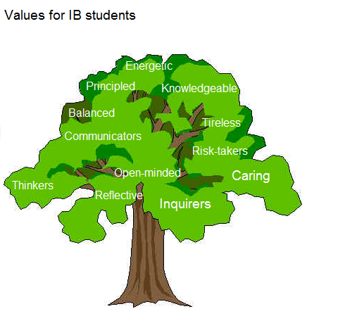

Tree of values by IB students of English A Language and Literature (supervisor Erika Puusemp)

